Queens Road Surgery
83 Queens Road
Consett
Co. Durham
DH8 0BW
www.queensroadsurgery.co.uk
Tel: 01207 585890
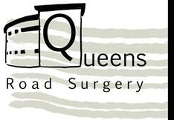

Full Name
Date of Birth
NHS Number (if known)
Contact Number
Home address (inc. postcode)
Today's Date
Travel Destination
Travel Dates

Please visit: www.travelhelthpro.org.uk/countries
Please review your vaccine history provided by the practice, if NaTHNaC has recommended any of the below vaccines, please tick and state when you last had this
Recommended | Last had
Diphtheria, polio & tetanus (combined)
Typhoid
Hepatitis A (including when combined with typhoid or hepatitis B
Cholera - see below

Cholera vaccine is usually only recommended for travel to remote places with little or no access to medical care. The vaccine is not highly effecting and best measures are good hand hygiene and using clean water
Usually, the cholera vaccine is recommended for:
- Volunteer/ aid workers in disaster relief situations where cholera outbreaks are likely
- Those traveling to work in refugee camps, areas affected by natural disasters
- Countries experiencing cholera outbreaks where care with food and water is difficult or not possible
Staff use ONLY
Appointment booked in 8 weeks
Task sent to practice nurse
Form scanned onto patient record

